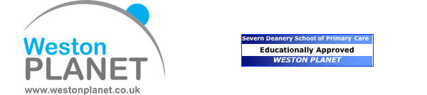

**P**rotected **L**earning **A**nd **N**ew **E**ducational **T**raining

Registered Charity Number 1156960 WESTON PLANET



PLANET Program for Thursday, 17th October 2024

Batch Country House

Batch Lane, Weston-super-Mare BS24 0EX

13:00 – 14:00 **Buffet Lunch**

14:00 – 15:15 **2ww Colorectal**

Mr Reuben West

Consultant Colorectal Surgeon at WGH

15:15 – 15:45 **Afternoon Tea**

15:45 – 17:00 **Hepatitis B and C for GPs**

Dr Kate Robson

Broadmead Medical Centre and Homeless Health Service, Bristol

**Alright my liver: testing for cirrhosis in the community**

Sally Tilden

Hepatology Clinical Nurse Specialist at UHBW

*The PLANET meeting is sponsored by Pharmaceutical Representatives*

GSK *has no influence over agendas and speakers and they are sponsoring by way of a promotional stand.*

Daiichi *has no influence over agendas and speakers and they are sponsoring by way of a promotional stand.*

Menarini *has no influence over agendas and speakers and they are sponsoring by way of a promotional stand.*

*Bayer has no influence over agendas and speakers and they are sponsoring by way of a promotional stand*